Book*, “The Unites States since 1945: A documentary reader.”*

*By Robert P. Ingalls and David K. Johnson.*

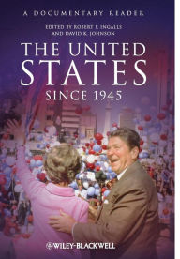

(718) 844-0987

213-53 39 Ave. Boulevard, Bayside, NY. 1361

October 20, 2016

Mr. Clarence Jefferson

History 129: Recent American civilization

234-15 56 Avenue

Bayside, NY 11364

Dear Proof. Jefferson

I want to express my gratitude for being so understandable and creative professor, I really enjoyed our lectures full of knowledge which are help me to be a more competitive student, however, it’s not all a bed of roses, regarding with the book that we must have to purchase, (*The Unites States since 1945: A documentary reader.)* many of my classmates felt that our required book it’s just too expensive, (500 hundred dollars) I would like to take this opportunity to see if there is other sources of information you may feel I could study and prepare myself for this amazing class without purchasing the book.

Sincerely,

Cristian Calleja